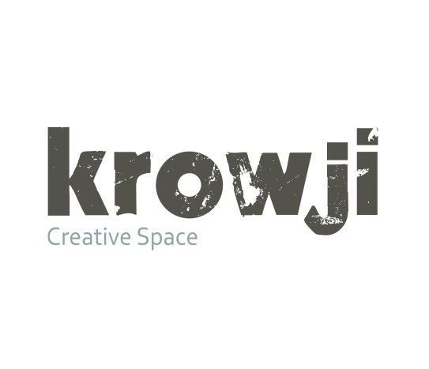

Application form for studio space
_______________________________________________________________________________________

‘Studio’: an unfurnished work space for artists, makers and organisations. We provide messy workshops, smart offices and everything in between.

Selection procedure and criteria

Please read through our list of FAQs on pages 6-9 of this document and complete this form as fully as possible. Your application will be considered on the extent to which it meets the following criteria:

- your need for studio space to develop your practice/business
- your commitment to use a workspace regularly
- your plans to grow your practice/business
- your commitment to continuing professional development

Please address these criteria within your answers required in section 3 and submit a CV and six images of your work with your application (or direct us to your website). Krowji tenants work in a variety of ways across the creative sector, so we understand that some of the following questions may not be directly relevant to your needs or practice – please feel free to answer them in the way that best suits you.

We aim to let applicants know if they have been successful as soon as possible, usually within 1-2 weeks. If we approve your application, but don’t have a space available, we’ll let you know, add you to our waiting list and keep you informed.

Section 1 - personal information
Name
Address
Postcode
Telephone
Email | Website
Social Media
Please state where you are currently working

Section 2 – workspace requirements
What is your practice/profession?

Approximately how much space do you think you require?

Floor area (or give dimensions if preferred)

Do you want a studio as a sole occupant? Yes |  |  |  | No
Are you willing to share a studio? Yes |  |  |  | No
If you have a preference, please indicate whether you would prefer to be in
the science block/main building/Percy Williams Building?

If your application is successful, what should we know about your needs and processes?

Please tick all those that apply and give as much detail as you can e.g. the type and level of noise

My work:
- is noisy
- is dusty
- creates fumes/smells
- involves running workshops/courses
- Other:

If your application is successful what optional extras might you need in your studio? Please tick all those that apply and give further details. All of the following come with an additional charge – see our FAQ below for more information.

- Phone line
- Broadband
- Sink
- 3 phase electricity
- Extraction unit
- Other:

Approximately how many hours a week do you expect to use your workspace, if your application is successful?

Can you give us a rough idea of your likely working hours?
This is not a ‘scoring question’, but the information may help us find
the most suitable space for you.

Section 3 – your practice/business
Please give a description of your work or the services you provide and tell us why you need a studio. Remember to refer to the selection criteria listed on page one. (You can expand these spaces or continue on a separate sheet if necessary.)

How long have you been a practising artist/maker / when did you set up your business?

Are you registered with the Inland Revenue as a self-employed practitioner?

Yes |  |  | No

If ‘No’, at what point do you intend to register?

We can offer advice to practitioners and also signpost you to other organisations that can help you set up in business.

Please list at least 3 examples of your work
For artists and makers this may be a list of projects, commissions, exhibitions and/or stockists.
For businesses and organisations this may be a list of clients, projects and/or events.

Please explain how you plan to increase your profile and market your work over the next 12 months. This does not have to be a full marketing or business plan but again, please give as much detail as possible.

How will you support yourself financially if your application for a studio is successful? For example give a percentage breakdown e.g. 30% p/t paid employment, 30% income from workshops/teaching, 40% from sales of work

Any further information you believe will support your application - for example brochures, websites, awards.

4. Reference
Please supply the name and contact details of someone who knows your work or circumstances and who would be willing to provide a reference. For example, this could be a previous landlord, a gallery owner or a staff member at Creative Skills.

Name:
Relationship to applicant:
Telephone:
Email:
Address:

5. How did you hear about the studios at Krowji?

6. Application check-list
Before you send us your application, have you remembered to:-
- Answer all the questions?
- Enclose or attach your CV or direct us to your website?
- Give all the information you can about your practice/business?
- Give details of a referee?
- Enclose up to 6 images of your work or direct us to your website?
- Complete equal opportunities monitoring form?

Please post your completed application and equal opportunities form to:
The Studio Selection Panel, Krowji, West Park, Redruth TR15 3AJ
Or email it to Elisa Harris at elisa@actcornwall.org.uk
If you have any further questions, please contact Elisa Harris on 01209 313200 or elisa@krowji.org.uk

Thank you for applying.

EQUAL OPPORTUNITIES MONITORING QUESTIONNAIRE

Creative Kernow & Krowji are working towards equal opportunities for all. To monitor the effectiveness of our policies we need to collect information from applicants on the key characteristics which relate to equal opportunities. The information collected will form a confidential record and it may be stored electronically or manually. It will be used only to monitor the operation of the Equal Opportunities policy which aims to ensure that no direct or indirect discrimination occurs on the grounds of sex, age, colour, race, marital/family status or disability. It will not be passed on to those making any selection decisions. Thank you for your assistance.

1 My gender is: Male Female

2 My age is: Under 25 25 – 34 35 – 44 45 – 54

55 – 65 over 65

3 I would describe my ethnic origin as:
(Ethnic origin questions are not about nationality, place of birth or citizenship. They are about colour and broad ethnic and cultural groups. UK citizens may belong to any of the groups shown. Please tick the category that you feel best reflects your ethnic origin.)

A | White
 |  | British
 |  | Irish
 |  | Cornish
 |  | Any other Mixed background, please write in
B | Mixed
 |  | White and Black Caribbean
 |  | White and Black African
 |  | White and Asian
 |  | Any other Mixed background, please write in
C | Asian or Asian British
 |  | Indian
 |  | Pakistani
 |  | Bangladeshi
 |  | Any other Asian background, please write in
D | Black or Black British
 |  | Caribbean
 |  | African
 |  | Any other Black background, please write in
E | Chinese or other ethnic group
 |  | Chinese
 |  | Any other, please write in
4 My household status is: Single/Divorced Married/settled partner Widowed

5 Do you consider yourself to have a disability? Yes No
This could include sensory/physical as well as chronic medical conditions, mental health problems and dyslexia/other specific learning difficulties

If so, please describe your disability:

6 Do you have any dependant children? Yes No

7 Do you have other dependant relatives? Yes No

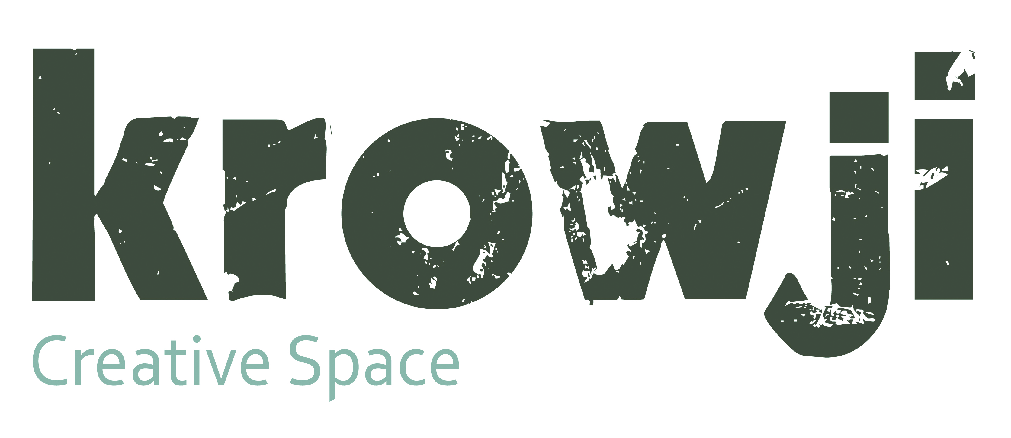

Frequently Asked Questions

‘Studio’: an unfurnished work space for artists, makers and organisations. We provide messy workshops, smart offices and everything in between.

Applying for a space

Am I eligible for a studio at Krowji?
Krowji welcomes applications from all those involved in cultural work, from creative practitioners to organisations that provide services to those working in the creative industries.

Are there any creative practices you can’t cater for?
We aim to cover the full range of arts and creative sector activities (see www.wikipedia.org/wiki/Creative_industries) but we don't currently have facilities for practitioners working in materials such as stone or metal because of the issues of noise and dust. If in doubt do please ask us - we try to be as flexible as possible, but we do have some parameters set by our sources of funding as an arts organisation.

Can I come and see the spaces?
As our studios aren’t open to the public the best time to see them is during Open Studios in May/June and Nov/Dec.

Studio viewings prior to submitting an application are subject to availability – please email info@krowji.org.uk
We are always very happy to arrange tours for groups such as University students or local community groups, please get in touch.

How many spaces are there at Krowji and how big are they?
We currently have over 100 shared and self-contained spaces with approx. 170 people using the site. Our spaces range from 45 sq ft – 800 sq ft with our current average size 120 sq ft. The studios in Percy Williams Building are mostly 245 and 530 sq ft.

Please visit http://krowji.org.uk/studios/studios-available to download the floorplans for our Percy Williams building which show availability, sizes and prices excluding VAT and electricity.

How can I get an application pack?
You can download the application pack from our website http://krowji.org.uk/workspaces/how-to-apply or email us to request a copy info@krowji.org.uk

How long does the application process take?
We aim to notify people within 1-2 weeks.

What can I do if my application is rejected?
If your application doesn’t meet our criteria we will do our best to advise you as to the next step to take – this may include applying to alternative studios that can cater better for your needs or seeking further professional development support and reapplying when you are more ready to take on a space.

How soon will I get a studio?
This can be difficult to predict and is dependent on the type of space you require e.g. small self-contained spaces are in high demand and tend not to become available as often as others. We operate mostly at around full capacity, but with over 100 spaces we have quite a high turnover and tenants only need to give one month’s notice.

How does the waiting list work?
We keep a waiting list of people who have successfully completed the application process and contact those highest on the list as and when a suitable space comes up to arrange a viewing.

Can I share my space?
Yes, we are happy for you to share your space. However, your friend or colleague will need to go through the application process and if you decide to give up your space the licence or lease will not automatically transfer to your studio share.

Can I sublet my studio?
In common with most other studio complexes, we are willing to consider requests for short-term sub-lets if a tenant is going to be away temporarily e.g. on a residency or short project contract, but we treat this on a case-by-case basis.

I’ve been allocated a studio! What next?
We will ask you to pay a deposit of a month’s rent to secure the space as yours. This is held until the end of your tenancy. We will then email you to arrange a convenient date to come and sign the paperwork and pick up the keys to your new studio. We’ll give you a welcome pack and make sure you have all the information you need.

Accessibility

For full details on disabled access please visit http://krowji.org.uk/studios/faq/disabled-access

Are the studios open 24 hours?
Yes, tenants have 24 hours access to their studio 365 days a year.

How will my clients know where to find me on site?
We have a list of all our tenants at Reception with their studio number and building name. The Percy Williams Building has an intercom system whilst the other buildings are locked to the public and require visitors to call the tenant to give them access. Of course we are happy to help any visitors who come to reception first.

How accessible are the studios?
Whilst the Percy Williams Building is DDA compliant and we have made a number of modifications and improvements to our existing spaces in the old buildings we regret that a small number of the studios in our older buildings don’t have disabled access. Please visit http://krowji.bywill.co.uk/studios/faq/disabled-access for more information.

How secure are the studios?
The external doors on our studio buildings or areas are kept locked at all times and we have a contract with Kestrel Guards who carry out 2 patrols every night. You can also install your own alarm system and link up to the Kestrel call out service - ask us for details.

Rents & Tenancy Agreements

How much do the studios cost?
Old Building Studios £7-9 per sq ft per year + VAT
Percy Williams Building £9-11 per sq ft per year + VAT
The rents vary according to the quality of space and the rate lowers as you go over a certain size bracket.

What does the rent include?
Many of our older studios are priced to include the cost of water and electricity, whilst other studios - including all those in the Percy Williams Building - have their own electricity meters. In this case tenants are invoiced quarterly according to their consumption.

What about business rates?
All tenants are responsible for their own Business Rates and there is currently a 100% small business rates relief for which all our tenants are eligible provided they are not already claiming relief on another property. We will give you the details you need in order to apply for rates relief.

How is the rent paid?
Rent is paid by standing order on 1st of every month.
We can also arrange quarterly or 6 monthly invoicing for those who prefer.

What happens if I fall behind on my rent?
We check the rent accounts at the end of each month and will contact you if there are any outstanding payments on your account. If you fall into financial difficulty the best thing to do is come and talk to us.

How long do I have to keep the studio?
We can tailor the tenancy agreements to suit your needs.

Short-term Sub-lease - for those who require complete flexibility we offer an annual agreement where tenants are only required to give 1 month’s notice.
or
3 year sub-lease – for those looking for more security we can offer a longer term contract of 3 years. There is a break clause and the notice period is 6 months.

Will my rent increase after a certain time?
We carry out annual rent reviews which take effect from the start of each tax year, 1st April. For those who take out a 3 year lease your rent will remain the same for the first three years before increasing in line with our current rates at the start of your 4th year.

What about insurance?
Krowji insures the building and all communal areas whilst tenants are responsible for their own spaces. For public liability insurance we recommend subscribing to a-n. If you wish we can refer you to our broker for advice.

How long can I have a studio for? Is there an exit policy?
We don’t operate an exit policy, however, Phase II of our redevelopment project will affect all the studios in our Science Block. As with Phase I we will give as much notice as possible, with 3 months being the minimum, and we hope to be able to find spaces for all current tenants elsewhere on site. We are yet to secure the funding for this phase and don’t envisage that the work will start for approximately 3-4 years but as always we will keep everyone informed.

Can I make changes to my space?
Yes, you are very welcome to make the space your own. We only ask that you run your ideas past us first (if you’d like to do more than just paint the walls) and ensure that the space can be returned to its original state should you decide to leave at a later date.

Facilities

Are the studios heated?
It is down to the tenant to bring in their own electric heater/s – this is the most efficient form of heating for buildings like ours where people are coming and going throughout the day and night. We ask tenants to be vigilant and advise using a timer.

Do the studios have phone lines and broadband?
This will depend on which building you are in and we ask that you indicate your needs in the application form. We have fibre to the premises and the PW Building is wired up ready for tenants to set up their own bespoke phone line and broadband connection. We can recommend a local service provider. For ‘low-end’ users we provide shared broadband service of up to 10mb at £10 + VAT per month. There is a setup fee of £75 + VAT. There is Wi-Fi in the Melting Pot Café which is free to all tea/coffee drinkers.

Are there shared kitchens/sink rooms?
Yes, each block has these in varying formats – the PW Building has separate tea and wash-up rooms on each floor. A few studios have their own fitted sinks and we can quote for installing sinks in the PW studios.

Will I be able to receive mail and packages at my studio?
Yes, all post and parcels are delivered to us at the main reception. All small post is put in your pigeonhole and we will notify you about parcels so that you can collect them from us.

Is there parking available?
Parking is generally available but not guaranteed – at times the site can be very busy. We don’t currently operate a permit system but may need to introduce this in a few years’ time as the site becomes busier.

Are there other rooms available to hire on an hourly/daily basis?
Yes, there are rooms behind the café which are hired out at £5 per hour and Miracle Theatre rent out their rehearsal space. Please contact us for more information.

Is there an exhibition space at Krowji?
Yes, we have an exhibition area which is dedicated to showcasing work by Krowji artists and we run exhibitions in the spring and autumn.

Do you help to promote your tenants’ work?
All of our tenants have their own page on our website and we promote tenants’ exhibitions, events and opportunities via social media and our monthly e-newsletter.

Does Krowji have any equipment for artists and makers to hire out e.g. kilns, print-making equipment, tools?
Although it is something we would like to see provided in the future, we are currently renting empty spaces which tenants are required to set up themselves. We have, however, installed a wash-out booth for print-makers to use which is based in the Science Block.

What kind of ventilation is available in the studios?
Most studios have windows but for those requiring an extractor fan/ventilation system it is down to the tenant to have this installed in consultation with us.

What other benefits are there to being a tenant at Krowji?
- On site professional development agency for creative practitioners – Creative Skills
- On site community arts funding team - FEAST
- Opportunities for community involvement
- Supportive and flexible site management team
- Access to office equipment e.g. A3 colour photocopier

Tenant Meetings, Events & Workshops

What can I get involved in as a tenant?
We run monthly skillshare sessions which offer an opportunity to socialise whilst learning something new from fellow tenants. Our artists and makers also run Studio Sessions every last Wednesday of the month where tenants take it in turns to host a gathering or critique in their studio.

What involvement is required?
We very much encourage tenants to take advantage of the events and opportunities here at Krowji, however, we are equally very understanding of those who wish to work completely independently.

Can I run workshops in my space?
Yes, many of our tenants run workshops and we encourage this kind of activity. We can also help to promote this for you by sharing your publicity material. Bear in mind that you will either need a self-contained space for this or you can hire one of our rooms behind the café. You’ll need to show that you have the appropriate insurance for this work.

When is Open Studios?
Krowji runs two Open Studios events each year, one in May/June time which is a Cornwall-wide event and run by Creative Skills who are part of Creative Kernow and a second which is in Nov/Dec and is purely for Krowji.

What should I do if I want to take part in Open Studios?
We email all our tenants when open studios is coming up to keep you well informed and ensure you don’t miss the deadlines.

I have an idea for something I’d like to run at Krowji, what should I do?
We love tenants to come to us with creative community project ideas and whilst we’re rarely able to offer financial support we can give advice and help with publicity. We are particularly keen to enable local schools and community groups to engage with us.

History and Premises

Who owns and runs Krowji?
Creative Kernow

Creative Kernow supports the production, promotion and distribution of work by creative practitioners in Cornwall because we believe in creativity's transformative power and want more people to benefit from it.

One of Cornwall’s key creative industries organisations, Creative Kernow was first established as Cornwall Arts Centre Trust (often known as ACT) in 1983 and is the umbrella organisation for:
• KROWJI
• CARN TO COVE
• CREATIVE SKILLS
• FEAST
• CORNWALL MUSIC FORUM
• CORNWALL 365

Our support is delivered through programmes which can touch everyone's lives:
- affordable managed workspace
- skills development
- a rural touring scheme
- investment in projects bringing together professional artists and communities
- being a creative hub
- helping the cultural and tourism sectors to work more closely together
- supporting young people to enter the creative workforce
- building international partnerships
- and many more

How long has Krowji been here?
We bought the former grammar school buildings in 2005.

What does Krowji mean?
Krowji is Cornish for workshop or shed – the spelling is the agreed modern form, but you often see Crowgey or Crougey as a farm name in mid and west Cornwall

